Nepal College of information Technology
Balkumari Lalitpur
Unit Test
Fall Semester 2008

Program : B.E Semester: VII
Time : 2hrs Year : III

FM : 75 PM : 35

Control System

1. a. Define open loop and closed loop system with suitable examples. Which system is more reliable to operate? Explain with suitable reasons. [8]
b. The overall transfer function of a negative feedback system is given by
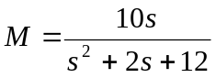
The feedback path transfer function is given by H(s)=1/s. Obtain the open loop transfer function. [7]
2. a. Write down the defining equation for the liquid level system shown in the below figure. Obtain their transfer function also. [7]
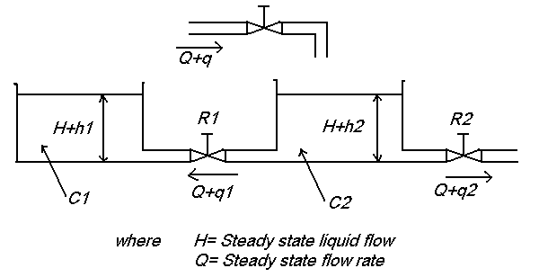

b. Draw the overall block diagram for armature controlled DC motor. Also find the overall transfer function. [8]
3. For the translational mechanical system is shown in figure below
[15]
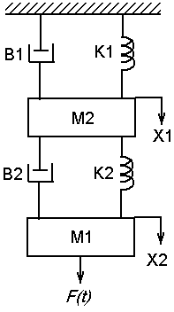

Find a) the force balance equation that describe the motion of the system
b) Obtain the force-voltage analogy and
c) Obtain the force-current analogy.
4. Find the overall transfer function C(s)/R(s) for the following system using both block diagram reduction technique and SFG. [15]

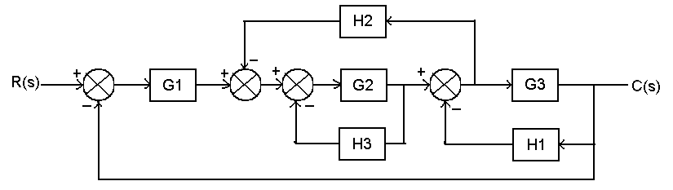

5. Write short notes on (any two) [5*2=10]
a) Linear approximation of non-linear system
b) Sensors
c) Human control system

